

Parul University

FACULTY OF ENGINEERING AND TECHNOLOGY

BACHELOR OF TECHNOLOGY

Computer Organisation and microprocessor Architecture Laboratory

(303105211)

IV SEMESTER

Computer Science & Engineering Department



Laboratory Manual

Session 2023-24

CERTIFICATE

This is to Certify that

Mr./Ms. ㅤㅤㅤㅤㅤ **VIJAY KUMAR** ㅤㅤㅤㅤㅤㅤㅤㅤㅤㅤㅤ ㅤㅤㅤ

With enrolment no. **2203051050620** has successfully completed his Laboratory experiments in Computer Organisation and microprocessor Architecture Laboratory (303105211)From the department of COMPUTER SCIENCE AND ENGINEERING ㅤ during the academic year 2023 - 2024ㅤㅤ



Date of Submission : ………………………. Staff In Charge: ……………………….

Head of department: ……………………….

|  |  |  |  |  |  |  |  |
| --- | --- | --- | --- | --- | --- | --- | --- |
| **Sr. No** | **Experimental Title** | **Page No** | | **Date of Performance** | **Date of Submission** | **Marks (10)** | **Sign** |
| **From** | **To** |
| 1. | Addition of two 8-bit numbers using 8085 |  |  |  |  |  |  |
| 2. | Write a program to add two 16 bit numbers. |  |  |  |  |  |  |
| 3. | Part A: write an 8085 assembly language to perform multiplication of two 8 bit nos.  Part B: write an 8085 assembly language to perform division of two 8 bit nos |  |  |  |  |  |  |
| 4. | Write a program to add blocks of 8-bit data stored in memory locations. |  |  |  |  |  |  |
| 5. | Write an 8085 assembly language program to find the minimum from two 8-bit numbers. |  |  |  |  |  |  |
| 6. | Part A. Write an assembly language program to sort data in ascending order.  Part B Write an assembly language program to sort data in descending order. |  |  |  |  |  |  |
| 7. | Write an 8085 assembly language program to get the minimum from block of n 8-bit number |  |  |  |  |  |  |
| 8. | Write a program to convert BCD to binary |  |  |  |  |  |  |
| 9. | Write a program to convert binary to BCD |  |  |  |  |  |  |
| 10. | Write an 8085 assembly language program to convert a given binary number into its equivalent ASCII number |  |  |  |  |  |  |
| 11. | Write an 8085 assembly language program to convert a given ASCII number into its equivalent binary  number |  |  |  |  |  |  |

**TABLE OF CONTENT**

# **PRACTICAL NO.1**

**AIM :** Addition of two 8 bit numbers using 8085

**APPARATUS :** sim 8085 online/offline software,internet,computer/laptop

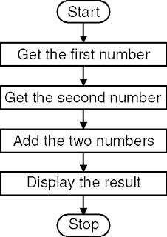

**FLOWCHART**

**:**

**CODE :**

**OUTPUT :**

# **PRACTICAL NO.2**

**AIM :** Write a program to add two 16 bit numbers.

**APPARATUS :** sim 8085 online/offline software,internet,computer/laptop

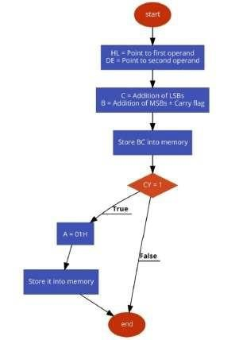

**FLOWCHART**

**:**

**CODE**

**:**

**OUTPUT :**

**CONCLUSION :**

After performing this practical we are able to add 2 16-bit numbers

# **PRACTICAL NO.3**

**AIM :** Part A: write an 8085 assembly language to perform multiplication of two 8 bit nos.

**APPARATUS :** sim 8085 online/offline software,internet,computer/laptop.

**CODE :**

**OUTPUT :**

**Part B**: write an 8085 assembly language to perform division of two 8 bit nos

**INPUT / OUTPUT :**

# **PRACTICAL NO.4**

**AIM :** Write a program to add blocks of 8-bit data stored in memory locations.

**APPARATUS :** sim 8085 online/offline software,internet,computer/laptop.

**CODE :**

**OUTPUT :**

# **PARCTICAL NO.5**

**AIM :** Write an 8085 assembly language program to find the minimum from two 8-bit numbers

**APPARATUS :** sim 8085 online/offline software,internet,computer/laptop.

**FLOWCHART :**

**CODE :**

**OUTPUT :**

# **PRACTICAL NO.6**

**AIM :** Part A. Write an assembly language program to sort data in ascending order.

**CODE :**

**OUTPUT :**

**Part B** : Write an assembly language program to sort data in descending order.

**CODE :**

**OUTPUT :**

# **PRACTICAL NO.7**

**AIM :** Write an 8085 assembly language program to get the minimum from block of n 8-bit number

**APPARATUS :** sim 8085 online/offline software,internet,computer/laptop.

**CODE :**

**OUTPUT :**

# **PRACTICAL NO.8**

**AIM :** Write a program to convert BCD to binary.

**APPARATUS :** sim 8085 online/offline software,internet,computer/laptop.

**CODE :**

**OUTPUT :**

# **PRACTICAL NO.9**

**AIM :** Write a program to convert binary to BCD

**APPARATUS :** sim 8085 online/offline software,internet,computer/laptop.

**CODE :**

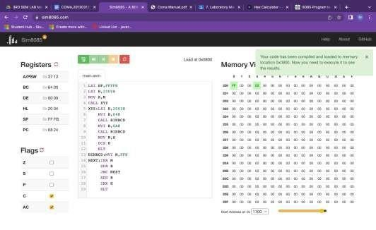

**OUTPUT**

**:**

# **PRACTICAL NO.10**

**AIM :** Write an 8085 assembly language program to convert a given binary number into its equivalent ASCII number

**APPARATUS :** sim 8085 online/offline software,internet,computer/laptop.

**CODE :**

**OUTPUT :**

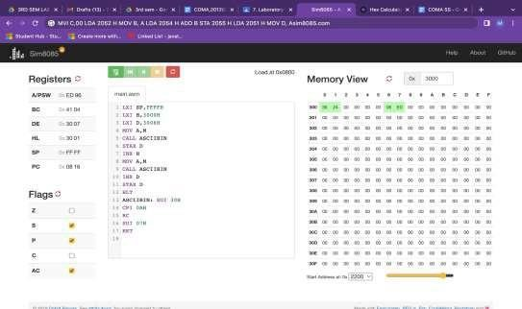

# **PRACTICAL NO.11**

**AIM :** Write an 8085 assembly language program to convert a given ASCII number into its equivalent binary number

**APPARATUS :** sim 8085 online/offline software,internet,computer/laptop.

**CODE :**

**OUTPUT :**

